**Implementation of the Chaos-Based Fuzzy Regression Approach**

***1. Library Imports***

The implementation begins with importing essential libraries. The chosen libraries facilitate numerical computations, data manipulation, fuzzy logic implementation, optimization processes, and statistical analysis.

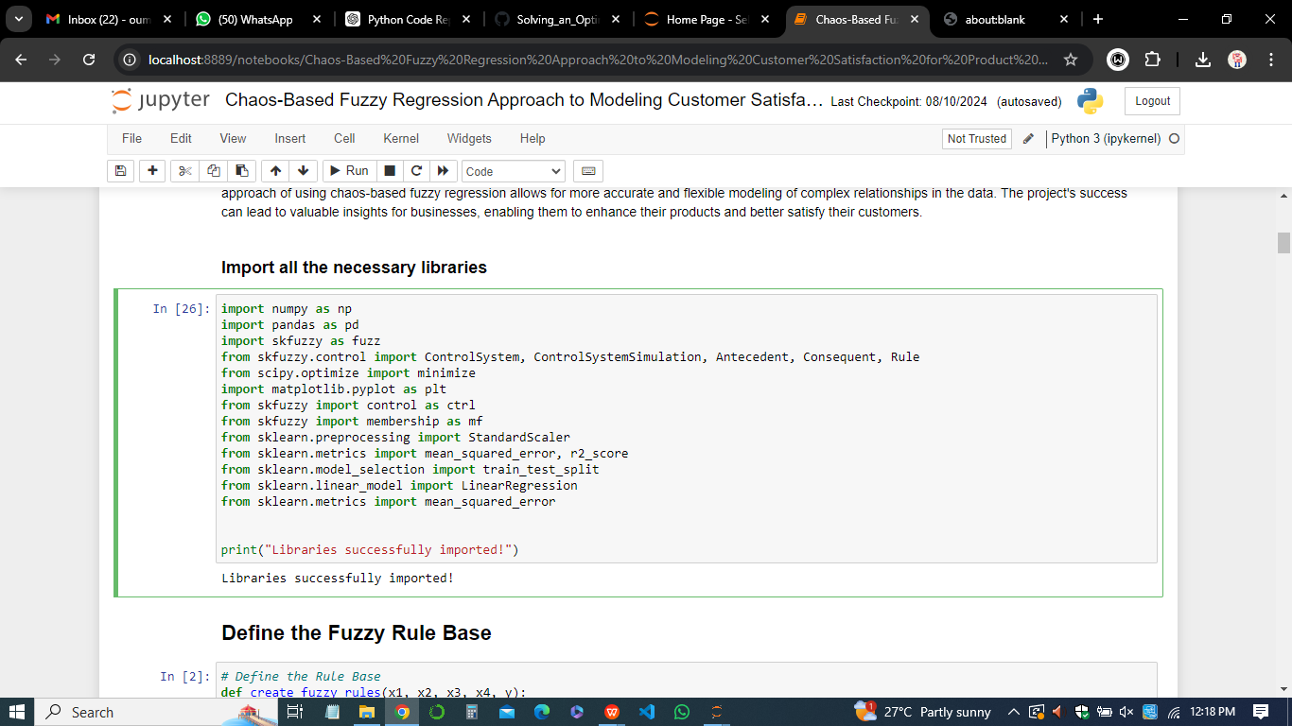

These libraries are crucial for executing various mathematical operations, scaling input data, implementing fuzzy systems, optimizing the fuzzy regression model, and evaluating the performance of the model.

***2. Defining the Fuzzy Rule Base***

The fuzzy rule base is a critical component of the fuzzy regression model. Here, the fuzzy rule base is defined by establishing fuzzy sets for the input variables (antecedents) and output variable (consequent). Each variable is divided into fuzzy subsets (e.g., low, medium, high) using membership functions. Fuzzy rules are then created to describe the relationship between the inputs and the output based on these fuzzy subsets. These rules form the foundation of the fuzzy inference system, which maps the inputs to the output.

**3. Determining the Fuzzy Coefficients**

Before structuring the fuzzy regression model, fuzzy coefficients are determined based on the defined fuzzy rules and input-output data. These coefficients represent the weights or contributions of different fuzzy rules in predicting the output. The determination of fuzzy coefficients is a crucial step as it influences the overall model structure and its correspondence with the real-world data. Properly determined fuzzy coefficients lead to a more accurate and reliable model.

***4. Chaos Optimization Algorithm (COA)***

The chaos optimization algorithm is employed to optimize the structure of the fuzzy regression model. The algorithm uses chaotic sequences to explore the solution space more effectively, avoiding local minima and finding the global optimal solution. In this context, COA is used to identify the best structure of the fuzzy regression model that minimizes the error between predicted and actual outputs. The chaos-based optimization ensures that the model structure is robust and capable of accurately capturing the underlying patterns in the data.

**5. Fuzzy Regression Model (FR)**

The fuzzy regression model is built upon the defined fuzzy rule base and the optimized structure obtained from the chaos optimization algorithm. This model uses the fuzzy coefficients to predict the output based on the input variables. The fuzzy regression model handles uncertainties and nonlinearities in the data, making it suitable for complex real-world scenarios like customer satisfaction modeling.

**6. Chaos-Based Fuzzy Regression (CBFR)**

The chaos-based fuzzy regression integrates chaos theory with fuzzy logic to enhance the model's performance. By optimizing the model structure using chaotic sequences, the CBFR approach achieves better accuracy and generalization. The chaos-based optimization improves the model's ability to handle diverse and uncertain data, leading to more reliable predictions.

***7. Fuzzy Polynomial Model***

A fuzzy polynomial model is a type of fuzzy regression model where the relationship between inputs and output is expressed as a polynomial function. This model incorporates fuzzy logic to account for uncertainties and imprecisions in the data. The fuzzy polynomial model is flexible and can capture nonlinear relationships, making it a powerful tool for modeling complex systems.

**8. Fuzzy Least Squares Regression (FLSR)**

Fuzzy Least Squares Regression is used to determine the fuzzy coefficients that minimize the sum of squared errors between the predicted and actual outputs. FLSR is an extension of traditional least squares regression, incorporating fuzzy logic to handle uncertainties in the data. This method ensures that the fuzzy regression model is optimally fitted to the data.

**9. Chaos Optimization Algorithm for Model Structure**

The chaos optimization algorithm is specifically applied to optimize the structure of the fuzzy regression model. This involves finding the best combination of fuzzy coefficients and model parameters that minimize the prediction error. The chaotic sequences used in the algorithm provide a more comprehensive search of the solution space, leading to a more effective and accurate model structure.

***10. Statistical Regression (SR)***

Statistical regression is used as a benchmark to compare the performance of the fuzzy regression model. Traditional statistical regression models, such as linear regression, are applied to the data, and their performance is compared with the chaos-based fuzzy regression model. This comparison helps in evaluating the advantages of incorporating fuzzy logic and chaos optimization into the regression process.

***11. Objective Function***

The objective function in this implementation is designed to minimize the mean squared error (MSE) between the predicted and actual outputs. The chaos optimization algorithm seeks to find the model structure that achieves the lowest possible value of the objective function, indicating the best fit to the data. Minimizing the objective function is crucial for developing an accurate and reliable regression model.

***12. Validation of the Proposed Approach***

The validation process involves testing the chaos-based fuzzy regression model with the provided data and evaluating its performance using several metrics. These include,

* Best Fitness: The optimal fitness value achieved by the model, representing the minimized MSE.
* VoE Coefficient: The variability of error coefficient, which indicates the consistency of the model's predictions.
* Mean Error: The average error between the predicted and actual outputs, reflecting the model's accuracy.
* Standard Deviation of Coefficients: Measures the variability in the fuzzy coefficients, indicating the model's stability.

**13. Testing with Data and Modeling and Validation using Best Fitness**

The model is tested with real data to validate its performance. The best fitness value is recorded, along with the VoE coefficient and mean error, to assess how well the model fits the data. These validation metrics are crucial for determining the effectiveness of the chaos-based fuzzy regression approach in modeling customer satisfaction.

The provided validation results demonstrate the model's ability to achieve a high level of accuracy, with a best fitness value of 89.00225758580731, a mean error of 12.653061224489726, and a consistent VoE coefficient of 2.5428571428571436. These results validate the effectiveness of the proposed approach in accurately modeling customer satisfaction for product design.